**MIGRATOry behaviour of Atlantic bluefin tuna entering the mediterranean**

Tom Carruthers[1], Antonio Di Natale[2], Matt Lauretta[3], Alfonso Pagá García2, Stasa Tensek2

*SUMMARY*

A total of 305 bluefin tuna were tagged in the Atlantic Ocean and Strait of Gilbraltar that were subsequently recaptured in either the Mediterranean or Strait of Gilbraltar. Of these tags, 68 were electronic tags and provided more detailed information about migration. These tag tracks and recaptures were used to evaluate current hypotheses regarding migration and spatio-temporal distribution of Atlantic bluefin tuna. In general migration was primarily to the Western Mediterranean in the Balearic Islands. Very few fish migrated to the furthest eastern area of the Mediterranean. Evidence from natural tags is consistent with movement from South Atlantic areas, an hypothesis that may be evaluated with additional tagging studies.

*KEYWORDS*

*Electronic tagging, migration, movement, bluefin*

# Introduction

Prior to electronic tagging experiments, historical information regarding Bluefin tuna migration from the Atlantic Ocean into the Mediterranean Sea came from tuna trap fisheries which followed the seasonal reproductive migration of fish either entering the Mediterranean for spawning or those leaving after spawning (Avolio Di Paola, 1805; D’Amico, 1816; Pavesi, 1889; Parona, 1919; de Buen O., 1923, 1924a, 1924b; de Buen F., 1927a, 127b, 1931; Sella, 1929b; Rodríguez-Roda, 1964, 1965, 1966, 1983; Sarà, 1961, 1964, 1965, 1973, 1983, 1998; Scaccini, 1965; Mather *et al.*, 1995). The historical distribution of the tuna traps along most of the Mediterranean coast and the temporal sequence of their fishing activities revealed the extent and timing of these migrations. Additional evidence of Atlantic fish entering the Mediterranean was provided by examining the types of hooks found in Bluefin tunas caught across the Mediterranean Sea (Tunisia, northern coast of Sicily, Turkey) (Sella, 1926a, 1926b, 1927, 1929a, 1930, 1931; Heldt, 1943; Genovese, 1959).

The modern fishery no longer captures this seasonal migratory behavior since very few tuna traps continue to operate in the Mediterranean (just three, all in the SW part of Sardinia, Italy) and most catches[4] are now taken in a handful of days in the open sea in the most important spawning areas where the purse-seiners operate. While it is not clear whether the accounts arising from the historical trap are relevant to the migration of the modern population[5] in any case these are accounts largely overlooked.

Recent data collection programmes, such as those initiated and coordinated by the ICCAT GBYP (Di Natale *et al*., 2017; Sissenwine and Pearce, 2017) have provided new insights into the migratory behaviour of Atlantic bluefin tuna (*Thunnus thynnus*, L.). These include movement of individuals along the Atlantic coast of Morocco (Quilez-Badía *et al.*, 2013 a, 2013b; Di Natale and Tensek, 2015) and distant migrations to areas uninhabited since the ‘80s such as Norway or very poorly documented in recent centuries such as Greenland (Di Natale, 2012).

The conventional tag data which are stored in the ICCAT BFT tag data base have been recently quality checked and analysed for studying the growth and the large scale movements of the Bluefin tuna (Pagá García *et al*., 2017).

Electronic tagging experiments have provided invaluable information regarding the ecology, migration and stock composition of Atlantic Bluefin tuna (Block *et al*. 2005, Lutcavage *et al*. 2012, Cermeño *et al*. 2015, Tensek *et al*., in press). Electronic tagging data are now one of the principal sources of data for identifying plausible hypotheses for stock mixing and movement that may be included in Management Strategy Evaluation (MSE) to identify robust management approaches (Butterworth and Punt, 1999). Additionally, these modelling programmes can be supported by the release and recovery information arising from conventional tagging.

The data obtained in recent years from the ICCAT GBYP electronic tagging activities were provided in real time to the scientific community by the GBYP reports, but in 2016 many sets of electronic tag data, deployed by other scientists, were made available thanks to the ICCAT GBYP data recovery activities or directly by some scientists who provided the data sets for the use of the Operating Model (OM) and the Management Strategy Evaluation (MSE) developed under the GBYP as requested by the ICCAT Commission and the SCRS (Anon., 2016, 2017b).

These combined efforts have provided a substantially richer data set for informing the MSE in terms tuna migration, distribution and range (although data are sparse in the central-southern Atlantic, Di Natale *et al*., 2013). Despite the availability of these data, a synthesis of new knowledge was yet to be prepared by the SCRS Bluefin tuna Species Group. Scientists of the 2017 SCRS Bluefin tuna data preparatory meeting requested an update in the current state of knowledge regarding migratory patterns for Bluefin tuna tagged in the Atlantic Ocean that subsequently moved into the various areas of the Mediterranean Sea. The purpose of this report is to provide such a synthesis.

# Methods

In this descriptive study we focus only on those conventional and electronic tags that were released in the Atlantic Ocean and the Strait of Gibraltar that subsequently entered the Mediterranean Sea. To identify different migratory behaviours, the Mediterranean Sea was divided into five areas (**Figure 1**):

* Strait of Gibraltar; the narrow gateway to the Mediterranean Sea; the exploitation rate in this area can be relatively high and therefore tagged fish are often recaptured preventing further displacement into the various Mediterranean areas.
* ‘Med Gate’; the southern part of the western Mediterranean Sea, another key passage where all fish coming from the Atlantic transit before reaching the main four spawning areas or for exiting the Mediterranean after spawning. Furthermore, this area is also one of the feeding areas for those Bluefin tuna which remains in the Mediterranean overwinter. Similarly to the Strait of Gibraltar numerous fishing activities are located in this area which can prevent further movement to other areas.
* ‘Balearic’; this area includes the true Balearic area, which is one of the four main spawning areas, but also the remaining parts of the Western Mediterranean Sea (the Catalan Sea, the Sardinian Sea, the Gulf of Lion, the Ligurian-Provençal basin and the western part of the Corsica Sea), which are important feeding areas.
* ‘Central Med’; this very large area includes two of the most important spawning areas (the southern Tyrrhenian Sea and the central-southern Mediterranean Sea), but also other important areas for the migratory movements (the Strait of Sicily, the eastern Ionian Sea and the southern Ionian Sea) and other important areas, for juveniles distribution, for feeding and overwintering (the Gulf of Hammamet, the Gulf of Gabes, the eastern Sardinian Sea, the central and northern Tyrrhenian Sea, the Ligurian Sea, the Strait of Messina, the Adriatic Sea, the eastern Ionian Sea). The bulk of the Mediterranean catches of the Bluefin tuna are historically coming from this large area.
* ‘East Med’; this other large area includes the last of the four main spawning areas (the Levantine Sea) and some areas where juveniles aggregate and where possibly some fish remains overwintering (the Aegean Sea, the Crete area, the Cyprus area and the Marmara Sea), due to the presence of suitable food chains. The migratory fish which are able to reach this area are those who escaped from the fishing activities in all the other four areas, therefore surely a minority fraction.

The Black Sea was not included in these area definitions despite its historical significance, Bluefin tuna disappeared from this sea in the early ‘80s. While there is evidence of fish slowly returning to this area (Di Natale, 2015), no tags have been recovered thus far.

A large number of both conventional and electronic tags have been released in the narrow area of the Strait of Gibraltar. In this descriptive analysis we separate these tags from those released in rest of the Atlantic Ocean.

## Data

The data used for this paper were collected and maintained by the ICCAT GBYP. The conventional tag data are available in the ICCAT Bluefin tuna tag data base and have been subject to processing and quality checks (Pagá García *et al*., 2017). From these databases the only tags that were retained for this analysis were those released in the Atlantic Ocean and Strait of Gilbraltar that were also recovered in the Mediterranean or Strait of Gibraltar (**Figure 2** and **Figure 3**). A total of 305 tags met this requirement. Of these 68 were electronic tags and 237 were conventional tags; 144 tags were deployed in the Atlantic and 161 tags were deployed in the Strait of Gibraltar (**Table 1**).

## Behaviours

We identified five distinct migratory behaviors for tagged fish entering the Mediterranean Sea, with movements to the:

* Strait of Gibraltar
* Med Gate
* Balearic area
* Central Med area
* East Med area
* Central Med area via the Balearic area
* Balearic area via the Central Med

Only electronic tags can provide information on the last two intra-Mediterranean movement types that help to understand mixing in the Mediterranean Sea.

# Results

Of the 62 electronic tags entering the Mediterranean Sea from the Atlantic Ocean, the majority either moved to the Med Gate area directly (36.8%) or moved to the Balearic area via the Med Gate (29.4%). Many fewer migrated to the Central Med (7.4%) and just one tag (1.5%) reached the East Med area (**Table 1**, **Figure 4**). 17.6% of the electronic tags moved to the central Med via the Balearic area, while 1.5% moved to the Balearic area via the central Med. Of the eight electronic tags entering the Mediterranean Sea from the Strait of Gibraltar, most (5 fish, 63%) migrated to the Balearic area with just one (13%) ending in the Central Med (**Table 1**, **Figure 5**). 5.9% of the electronic tags popped off in the Strait of Gibraltar.

The mean distribution of electronic tags entering the Mediterranean(**Figure 6**) further reveals the Western bias of the fish distribution.

The migratory behavior of the conventional tags is provided in detail in **Table 2**. Conventional tags ranked differently, with a considerable discrepancy between the tags deployed in the Atlantic and those deployed in the Strait of Gibraltar. In total, 59.1% of the conventional tags were reported from the Strait of Gibraltar (the high percentage is induced by the tags which were deployed in the same area). One in six conventional tags were recovered in the Balearic area, and around the same fraction (15%) from the central Med. Just 7.2 % were recovered from the Med Gate area, while just 4 (1.7 %) reached the East Med.

# Discussion

At the beginning of the ICCAT GBYP it was decided to explore various hypotheses about a possible sub-stock structure of the eastern Atlantic Bluefin tuna within the Mediterranean Sea. A central recommendation of the SCRS and the GBYP Steering Committee was to carry out an intense multi-year set of analyses, based both on the micro-chemical and the genetic approaches to explore the various hypotheses regarding mixing and stock structure. All of these analyses which included samples from most Mediterranean areas and age classes, supported the conclusion that there was no significant differentiating pattern in the samples (Di Natale *et al*., 2017). After the discussion at the Tuna Future Symposium in Monterey (USA) in February 2016, it was decided to perform an additional experiment, by using in parallel (on the same samples) both the SNPs and the microsatellites for the genetic analyses. Even these analyses corroborated the lack of any genetic differentiation within the Mediterranean Sea (Arrizabalaga, 2017). This result counters the pre-conceptual hypotheses which were based mostly on historical descriptions of Bluefin tuna previously migrating to the Black Sea or on ideas such as the isolation of some Bluefin tuna spawners in the Balearic Sea.

Uncertainty remains over an unknown portion of so called “resident” fish (hypothetically the majority) that stay for more than one year within the Mediterranean Sea (Di Natale *et al*., 2005). Evidence for overwintering in the Mediterranean is relative recent (GBYP REF). It is still unknown whether some Bluefin tuna do not leave the Mediterranean Sea. The current working hypothesis is that resident fish spawn in any of the Mediterranean spawning areas alongside those migrating from the Atlantic. This degree of mixing is poorly understood. Even less is known about the degree of inter-annual and seaosnal variability in the relative magnitude of resident and migratory fish in the Mediterranean.

Thus far, there is little evident to support hypothetical “spawning homing” to the various spawning areas. This is likely complicated by the ‘multi-spawning’ behavior of Bluefin tuna in which multiple spawning events can occur in a period of 3 to 6 weeks (Marino *et al*., 2005, Piccinetti *et al*., 2013). These may potentially occur in more than one area over the same spawning season, further increasing the likelihood of mixing within the Mediterranean Sea. This behavior may be central to the resilience of Bluefin tuna which has persisted over the centuries to varying exploitation pressures within the Mediterranean Sea (Tinti *et al*. 2016).

There are a number of phenomena that complicate the interpretation of the tagging data presented here. Conventional tag recoveries rely on reporting by commercial fisheries. It follows that the likelihood of recording a conventional tag recapture depends on the regional exploitation rate and the tag reporting rate, both of which vary widely among the areas of the Mediterranean. Although a central objective of the GBYP has been to improve tag reporting rates, these are still nil or almost nil in some areas and by certain fisheries. For the electronic tags, the principal limitation is premature release (and hence a bias toward recaptures near releases), which can be caused by tag failure and capture by fishing which are difficult to diagnose given the data reported by the tag (Tensek *et al*., 2017).

Both conventional and electronic tags are subject to capture by fishing operations. Given further tagging studies it may be possible to quantify the ‘survival’ rate of conventional and electronic tags as they migrate from the Western Mediterrnean to the East through the various fishing operations.

Acknowledging the phenomena above, a descriptive account of the tagging data leads to a number of observations:

1. Most of the fish tagged in the Atlantic and in the Strait of Gibraltar (46.9%) are intercepted in the Strait of Gibraltar. The majority of these are fish conventionally tagged in the Strait of Gibraltar and reported from the same area (88%). Relatively few fish tagged in the Atlantic with conventional tags are intercepted in the Strait of Gibraltar (7%). The percentage of electronic tags which popped-off in the Strait is also very low (3%). These data are the product of intense fishing activity and a relatively high reporting rate, particularly in the northern side of the Strait (REF)
2. The tagged fish which are showing-up in the Med Gate, an essential transit area, is relatively low (13.9%), The percentage of conventionally tagged fish in the Atlantic and in the Strait of Gibraltar which are intercepted in the Med Gate is relatively low (7.2%). The percentage is very low for the fish tagged in the Strait of Gibraltar (3%), while it is much higher for those tagged in the Atlantic (15%); this is likely attributable to the large fraction of short-term recaptures in the Strait of Gibraltar (point a above). For electronic tags the percentage is lower than may have previously been hypothesized (36.8%, but 42% for those fish tagged in the Atlantic). Again the discrepancy among conventional and electronic tag data in this area can be attributed to less fishing activity and an extremely low tag reporting rate (REF).
3. The number of tags (either electronic or conventional) deployed in the Atlantic and in the Strait of Gibraltar which popped-up or have been reported in the Balearic/western Mediterranean area is relattively high (20%). The percentage is higher for the electronic tags (29.4%), with a very high percentage related to fish electronically tagged in the Strait of Gibraltar (63%) and a low percentage for the fish electronically tagged in the Atlantic (25%). The percentage is lower for the conventional tags (17.3%) particularly for the effect of those fish tagged in the Strait of Gibraltar (3%), while it is much higher for those tagged in the Atlantic (46%), for the same possible motivations reported in the previous point. The image partly changes when considering that an additional 2% of the electronic tags popped-off in the area after transiting in the Balearic area, which brings the percentage of the electronic tags in this area to 30.9% and the total percentage of both types of tags to 20.3%. This area, which is a zone under the direct influence of Atlantic-origin waters, has an intense but mostly seasonal fishing activity and a reasonably high tag reporting rate (REF)
4. The number of tags (either electronic or conventional) deployed in the Atlantic and in the Strait of Gibraltar which popped-up or have been reported in the Central Mediterranean area is moderate (13.1%), particularly when considering that the area includes two of the four main spawning areas (the southern Tyrrhenian Sea and the southern-central Mediterranean Sea). This is higher (30%) of the conventional tags deployed in the Atlantic Ocean. While the percentage of conventional tags moving directly to Central Med is much lower (7.4%) for electronic tags, an additional fraction (20%) arrive via the Balearic area bringing the percentage of the e-tags in this area to 19.1% and the total percentage of both types of tags to 17.1%. The large area has an intense fishing activity and a highly variable tag reporting rate, depending on the zone and the fishery (REF).
5. The number of tags (either electronic or conventional) deployed in the Atlantic and in the Strait of Gibraltar which popped-up or have been reported in the Eastern Mediterranean area is very low (1.6%). The percentage is nil for the conventional tags deployed on fish tagged in the Strait of Gibraltar. Again this is probably due to the high fraction of recaptures of these fish shortly after release in the Strait of Gibraltar area. The single pop-off (2%) of the electronic tags confirm there is mixing among fish originating from the Atlantic. This follows opposite movements from the eastern Med to the Atlantic which have been identified previously (Di Natale *et al*., 2017). This area has an intense seasonal fishing activity in some parts but the tag reporting and recovery rates are very poor and even nil for some fishing operations.

Some of the W-E “filtering” problems could be potentially (even if always partly) overcome by considerably increasing the number of electronic tags deployed on Bluefin tuna when entering in the Mediterranean. However GBYP tagging programmes over the last seven years suggest that such an experiment is expensive and the data quality may be hampered by premature release. An area for future investigation is the use of the bluefin MSE framework to quantifying the potential value of additional electronic tagging data.

While the limitations of electronic tagging are established it remains the only way to evaluate numerous hypotheses relating to: spawning migration within the Mediterranean Sea; intra-Mediterranean movements during the spawning season; overwintering of fish; inter-annual variability in movement and its correlation with oceanographic and environmental aspects.

There are other “tags” that have been not taken into account in this work: they are the natural marks (round scars) derived from bites made by the small-tooth cookie-cutter shark (*Isistius brasilensis*) (**Figure 9** and **Figure 10**). This pelagic shark is not present in the Mediterranean Sea and it is mostly found in the waters of the South-West Atlantic. The presence of these natural marks in Bluefin tuna fished in the Mediterranean Sea is well known (Arena, 1985, 1988a, 1988b; Di Natale *et al*., 2013) and are most commonly found on large males. The percentage of Bluefin tuna with natural marks in the Italian purse-seine catches in the ‘80s was about 2% and about 98% of these tunas with natural marks were large males. These observations support new hypotheses about sex-specific migratory behavior to and from areas currently outside of the focus of Atlantic Bluefin science and management.

# Acknowledgements

This work was carried out under the provision of the ICCAT Atlantic Wide Research Programme for Bluefin Tuna (GBYP), funded by the European Union, several ICCAT CPCs, the ICCAT Secretariat and by other entities (see: http://www.iccat.int/GBYP/en/Budget.htm). The contents of this paper do not necessarily reflect the point of view of ICCAT or other funders and in no ways anticipate ICCAT future policy in this area.

# References

Anon. 2016, Aggregated electronic tagging data for use in operational modelling of Atlantic bluefin tuna. Available at: <https://github.com/ICCAT/abft-mse/blob/master/Data/Raw/PSAT/ALL_BFT_ElectronicTags_01122015.csv> [accessed Nov 2016]

Anon., 2017a, Bluefin tuna, ICCAT Biennial Period Report, 2016-2017, Part 1 (2016), vol. 2: 91-126.

Anon., 2017b, Report of the 2017 ICCAT SCRS Bluefin Tuna Data Preparatory Meeting. Available at: <http://iccat.int/Documents/Meetings/Docs/2017_BFT_DATA_PREP_ENG.pdf>

Arena P., 1985, La pesca del tonno in Sicilia. Atti Conv.Pesca e Trasf. Prod. Itt. Siciliani, Trapani: 23-28.

Arena P., 1988a, Risultati delle rilevazioni sulle affluenze del tonno nel Tirreno e sull’andamento della pesca da parte delle “tonnare volanti” nel triennio 1984-1986. MMM-CNR, Atti Seminari UU.OO. Resp.Prog. Ric., Roma: 273-297.

Arena P., 1988b, Rilevazioni e studi sulle affluenze del tonno nel Tirreno e sull’andamento della pesca da parte delle “tonnare volanti” nel quadriennio 1984-1988. Report to: ESPI, Ente Siciliano per la Promozione Industriale, Palermo, 1-55, I-XI.

Avolio Di Paola F., 1805, Delle Leggi Siciliane intorno alla Pesca. Reale Stamperia, Palermo : 1-239.

Arrizabalaga, H. 2017. Short term contract for biological studies ICCAT GBYP 09/2016 of the Atlantic-wide research programme on bluefin tuna. Available at: [http://www.iccat.int/GBYP /Documents/](http://www.iccat.int/GBYP%20/Documents/) BIOLOGICAL%20STUDIES/ PHASE%206/ Biological_Studies_AZTI.pdf

Block B. A., Teo S.L.H., Walli A., Boustany A., Stokesbury M.J.W., Farwell C.J., Weng K.C., Heidi D., Williams T.D., 2005, Electronic tagging and population structure of Atlantic bluefin tuna. Nature. 434: 1121-1127.

Butterworth D.S., Punt A.E., 1999, Experiences in the evaluation and implementation of management procedures. ICES J. Mar. Sci. 56, 985-998.

Cermeño P., Quilez-Badia G., Ospina-Alvarez A., Sainz-Trapaga S., Boustany A., Seitz A.C., Tudela S., Block B.A., 2015, Electronic tagging of Atlantic bluefin tuna (*Thunnus thynnus,* L.) reveals habitat use and behaviors in the Mediterranean Sea. PLoS ONE 10 (2): e0116638. doi: 0.1371/journal.pone.0116638.

D’Amico F.C., 1816, Osservazioni pratiche intorno alla pesca, corso e cammino de’ tonni. Società Tipografica, Messina: 1-164.

de Buen F., 1927a, Sobra la biología del atún, su pesca y conservación de sus carnes. Bol. Pescas, 12 (128) : 108-110.

de Buen F., 1927b, Notes et bibliographie sur la biologie du thon. Proc.-Verb. Cons. Explor. Mer., 44: 98-107.

de Buen F., 1931, El supuesto paso por el estrecho de Gibraltar del atún en su emigración genética. CIESM VI: 405-409.

de Buen O.,1923, Biología del atún. En: O. de Buen (dir.), Resultados de las campañas realizadas por acuerdos internacionales, Madrid, 1: 1-118.

de Buen O., 1924a, Las migraciones del atún en las costas Atlánticas del Sur España. Bol. Pescas, Madrid, 9 (92-93): 93-95.

de Buen O., 1924b, Les migrations du thon (*Orcynus thynnus*) sur les côtes atlantiques du Sud de l’Espagne. C.R. Acad. Sc., Paris, 178: 1104-1106.

Di Natale A., 2012, New data on the historical distribution of Bluefin tuna (*Thunnus thynnus*, L.) in the Arctic Ocean. Collect. Vol. Sci. Pap., ICCAT, 68 (1): 102-114.

Di Natale A., 2015, Revision of the historical and biological evidences about a population of Bluefin tuna (*Thunnus thynnus*, L.) in the eastern Mediterranean and in the Black Sea. Collect. Vol. Sci. Pap., ICCAT, 71 (3): 1098-1124.

Di Natale A., Idrissi M., 2012, Factors to be taken into account for a correct reading of tuna trap catch series. Collect. Vol. Sci. Pap., ICCAT, 67 (1): 242-261.

Di Natale A., Tensek S., 2016, ICCAT Atlantic-wide Research Programme for Bluefin tuna (GBYP) : Activity report for the last part of Phase 4 and the first part of Phase 5 (2014-2015). Collect. Vol. Sci. Pap., ICCAT, 72 (6): 1477-1530.

Di Natale A., Mangano A., Piccinetti C., Ciavaglia E., Celona A., 2005, Bluefin tuna (*Thunnus thynnus* L.) line fisheries in the Italian seas. Old and recent data. Collect. Vol. Sci. Pap., ICCAT, 58 (4): 1285-1295.

Di Natale A., Idrissi M., Justel Rubío A., 2013, The mistery of Bluefin tuna (*Thunnus thynnus*) presence in the South Atlantic in recent years. Collect. Vol. Sci. Pap., ICCAT, 69 (2): 857-868.

Di Natale A., Tensek S., Pagá García A., 2016, Preliminary information about the ICCAT GBYP activities in Phase 5. Collect. Vol. Sci. Pap., ICCAT, 72 (6): 1589-1613.

Di Natale A., Tensek S., Pagá García A., 2017, ICCAT Atlantic-wide Research Programme for Bluefin Tuna (GBYP). Activity report for the last part of Phase 5 and the first part of Phase 6 (2015-2016). SCRS/2016/193, Collect. Vol. Sci. Pap., ICCAT, 73 (7): 2424-2503.

Genovese S., 1959, Ami trovati in tonni (*Thunnus thynnus* L.) catturati in Sicilia e Calabria. Atti Soc.Pelor.Sc.Fis.Mat.Nat., V(4).

Heldt H., 1943, Etude sur le thon, la daurade et les muges. Histoires d’écailles et d’hameçons. Stat. Océan. Salammbô, Brochure 1 : 1-48.

Lutcavage M.E., Galuardi B., Lam T.C.H., 2012, Predicting potential Atlantic spawning grounds of western Atlantic bluefin tuna based on electronic tagging results, 2002-2011. Collect. Vol. Sci. Pap., ICCAT. 69 (2): 955-961.

Marino G., Candi G., Di Marco P., Longobardi A., Priori A., 2005, Supporto scientifico per la riproduzione controllata di grandi pelagici: *Seriola dumerilii* e *Thynnus thynnus*. ICRAM, Relazione finale VI Piano Triennale della Pesca e dell’Acquacoltura. Progetto di Ricerca 6C83.

Mather F.J.III, Mason J.M., Jones A.C., 1995, Historical document: Life History and Fisheries of Atlantic Bluefin Tuna. NOAA Tech. Mem., NMFS-SEFSC, 370: 1-165.

Pagá García A., Tensek S., Di Natale A., 2017, Bluefin tuna (*Thunnus thynnus*) growth and displacements derived from conventional tags data. SCRS/2016/143, Collect. Vol. Sci. Pap., ICCAT, 73 (6): 2150-2163.

Parona C., 1919, Il Tonno e la sua pesca. R. Comit. Talass. Ital., Venezia, Mem. LXVIII: 1-259.

Pavesi P., 1889, L’industria del Tonno. Relazione alla Commissione Reale per le Tonnare. Min. Agric. Indust. Comm., Roma, Tip. Eredi Botta: 1-254.

Piccinetti C., Di Natale A., Arena P., 2013, Eastern Bluefin tuna (*Thunnus thynnus*, L.) reproduction and reproductive areas and seasons. Collect. Vol. Sci. pap., ICCAT, 69 (2): 891-912.

Quílez-Badia G., Cermeño P., Tudela S., Sainz Trápaga S., Graupera E., 2013, Spatial movements of bluefin tuna revealed by electronic tagging in the Mediterranean Sea and in Atlantic waters of Morocco in 2011. Collect. Vol. Sci. Pap., ICCAT, 69 (1): 435-453.

Quílez-Badia G., Cermeño P., Sainz Trápaga S., Tudela S., Di Natale A., Idrissi M. Abid N., 2013, 2012 ICCAT-GBYP pop-up tagging activity, in Larache (Morocco), Collect. Vol. Sci. Pap., ICCAT, 69 (2): 869-877.

Rodriguez-Roda J., 1964, Movimientos migratorios del atun, *Thunnus thynnus* (L.), deducidos por nuestras propias “marcaciones” en aguas españolas. Publicaciones tecnicas de la junta de estudios de pesca, Direccion General de Pesca Maritima, Madrid, 3: 279-304.

Rodriguez-Roda J., 1965, Sobre las fluctuaciones en la produccion de atunes de las almadrabas sudatlanticas, Publicaciones Tecnicas de la Junta de Estudios de Pesca, Madrid. 4: 205-209.

Rodriguez-Roda J., 1966, El atún, *Thunnus thynnus* (L.), de la costa sud-atlántica de España en la campaña almadrabera del año 1964 y consideraciones sobre las fluctuaciones periódicas. Investigación Pesqueras, Barcelona, 30: 9-35.

Rodríguez-Roda, J., 1983. Lo que sabemos sobre la biología del atún. In: Ibérica, actualidad científica, número, 240: 23-26.

Sarà R., 1961, Observations systématiques sur la presence du thon dans les madragues siciliennes. Proc. Gen. Fish. Coun. Médit., 6: 41-61.

Sarà R., 1964, Données, observations et commentaires sur la présence, le comportement, les caractéristiques et les migrations des thons en Méditerranée. Proc. Gen. Fish. Coun. Medit. 7, 37: 371-388.

Sarà R., 1965, Sur la présence du thon rouge (*Thunnus thynnus*) le long des côtes d’Italie. Proc. Gen. Fish. Coun. Médit., 8:73-77.

Sarà R., 1973, Sulla biologia dei tonni (*Thunnus thynnus* L.). Modelli di migrazione ed osservazione sui meccanismi di migrazione e di comportamento. Boll. Pesca Piscic. Idrobiol., 28: 217-243.

Sarà R., 1983, Tonni e Tonnare, Una Civiltà, una Cultura. Libera Università di Trapani Ed., Trapani: 1-128.

Sarà R., 1998, Dal mito all’aliscafo. Storie di Tonni e Tonnare. Banca Aegusea Ed., Favignana-Palermo: 1-271.

Scaccini A., 1965, Biologia e pesca dei tonni nei mari italiani. Ministero Marina Mercantile, Mem. 12. 101 p.

Sella M., 1926a, Altri fatti sopra la migrazione dei tonni accertati per mezzo degli ami. Rend. Reale Accad. Dei Lincei, Roma, IV, ser.6, 2 sem.(5-6): 223-227.

Sella M., 1926b, Le migrazioni dei tonni studiate per mezzo degli ami. Atti R. Accad. Dei Lincei, Roma, III, ser.6, 1 sem.(II): 696-700.

Sella M., 1927, Les migrations des thons étudiées par le moyen des hameçons. Bull. Trav. Pub. Stat. Aquicul. Pêche, Castiglione, 2 : 101-136.

Sella M., 1929a, Migrazioni ed habitat del tonno (*Thunnus thynnus* L.) studiati col metodo degli ami, con osservazioni sull’accrescimento, sul regime delle tonnare, ecc. Mem. R. Com. Talass. Ital., 16: 3-24.

Sella M., 1929b, Biologia e pesca del tonno (*Thunnus thynnus* L.). Atti Conv. Biol. Mar. Appl. Pesca, Messina, Giugno 1928: 3-32.

Sella M., 1930, Distribution and migrations of the tuna (*Thunnus thynnus* L.) studied by the method of hooks, and other observations. Internationale Revue des gesamenten Hydrobiologie und Hydrographie, 24 (5/6): 445-466.

Sella M., 1931, The tuna (*Thunnus thynnus* L.) of the Western Atlantic. An appeal to fishermen for the collection of hooks found in tuna fish. Internationale Revue des gesamenten Hydrobiologie und Hydrographie, 25 (1/2): 46-47.

Sissenwine M., Pearce J., 2017, Second review of the ICCAT Atlantic-wide Research Programme on Bluefin tuna. ICCAT GBYP Phase 6, 2016). SCRS/2016/192, Collect. Vol. Sci. Pap., ICCAT, 73 (7): 2340-2423.

Tensek S., Di Natale A., Pagá García A., 2017, ICCAT GBYP PSAT tagging: the first five years. SCRS/2016/138, Collect. Vol. Sci. Pap., ICCAT, 73 (6): 2058-2073.

Tinti, F., Puncher, G.N., Cariani, A. 2016. Historical generic samples collected in old times in the Eastern Mediterranean Sea, in the Marmara Sea or in the Black Sea, including the genetic analysis of these samples (GBYP Project 04/2016). Available at: <http://www.iccat.int/> GBYP/ Documents/ DATA%20RECOVERY/ PHASE%205/HISTORICAL_GENETIC_REPORT_PHASE5_UNIBO.pdf

## Table 1. The frequency of movement types of electronic and conventional tags originating from the Atlantic and Strait of Gibraltar. Note that multistage movement types (e.g. ‘to central Med via Balearic’) cannot be determined from conventional tag release and recapture information.

|  |  |  |  |  |  |  |  |
| --- | --- | --- | --- | --- | --- | --- | --- |
|  | Tag type: | **Electronic** | |  | **Conventional** | | **all** |
|  | Origin: | **Atlantic** | **Strait of Gibraltar** |  | **Atlantic** | **Strait of Gibraltar** | **Total** |
|  |  | **Number of tags** | | | | | |
| **Movement type** | **To Strait of Gibraltar** | 2 | 2 |  | 6 | 134 | **144** |
| **To Med Gate** | 25 | 0 |  | 13 | 4 | **42** |
| **To Balearic** | 15 | 5 |  | 36 | 5 | **61** |
| **To Central Med** | 4 | 1 |  | 25 | 10 | **40** |
| **To Eastern Med** | 1 | 0 |  | 4 | 0 | **5** |
| **To Central Med via Balearic** | 12 | 0 |  | 0 | 0 | **12** |
| **To Balearic via Central Med** | 1 | 0 |  | 0 | 0 | **1** |
|  | **Total** | **60** | **8** |  | **84** | **153** | **305** |
|  |  | **68** | |  | **237** | |  |
|  |  |  |  |  |  |  |  |
|  |  | **Percentage by origin and type** | | | | | |
| **Movement type** | **To Strait of Gibraltar** | 3% | 25% |  | 7% | 88% | **47,2%** |
| **To Med Gate** | 42% | 0% |  | 15% | 3% | **13,8%** |
| **To Balearic** | 25% | 63% |  | 43% | 3% | **20,0%** |
| **To Central Med** | 7% | 13% |  | 30% | 7% | **13,1%** |
| **To Eastern Med** | 2% | 0% |  | 5% | 0% | **1,6%** |
| **To Central Med via Balearic** | 20% | 0% |  | 0% | 0% | **3,9%** |
| **To Balearic via Central Med** | 2% | 0% |  | 0% | 0% | **0,3%** |

**Table 2. Number and percentages of conventional tags deployed in the Atlantic Ocean and in the Strait of Gibraltar and recovered in the Strait of Gibraltar and in the Mediterranean Sea**



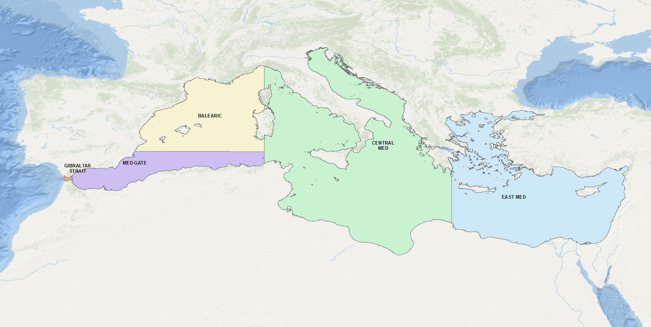

**Figure 1.**  Areas defined for studying the distribution of tags for Bluefin tunas tagged in the Atlantic which popped-off or were recovered in the various parts of the Mediterranean Sea.

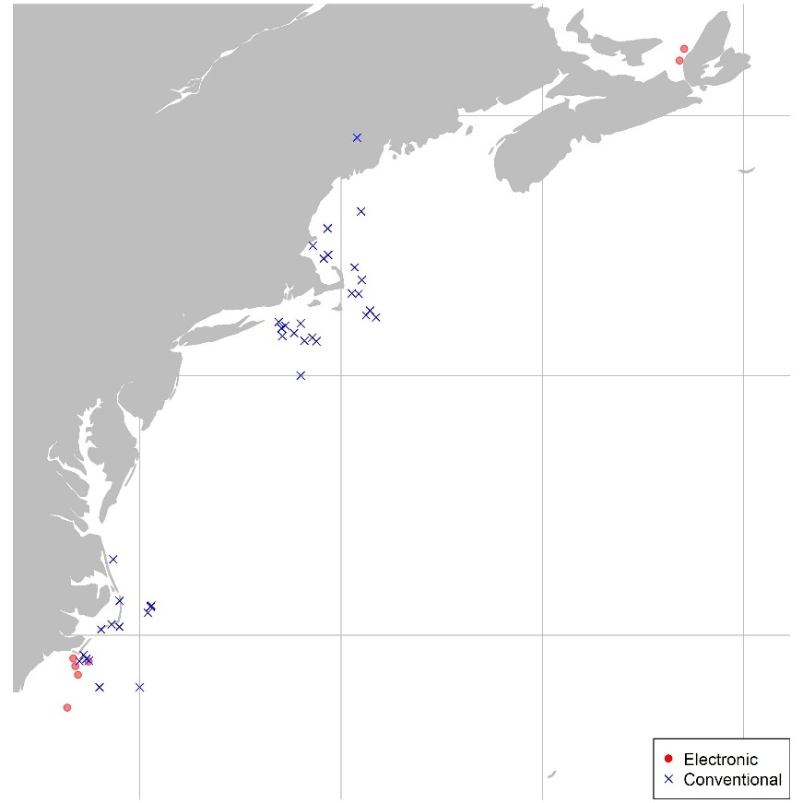

**Figure 2.** Origin (western areas) of electronic and conventional tags entering the Mediterranean

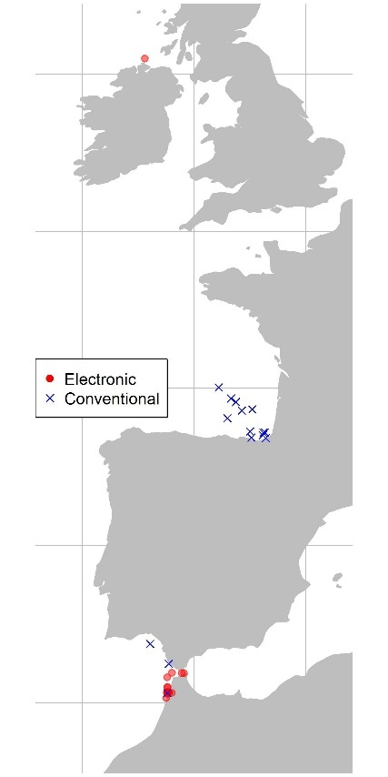

**Figure 3.** Origin (Eastern areas) of electronic and conventional tags entering the Mediterranean

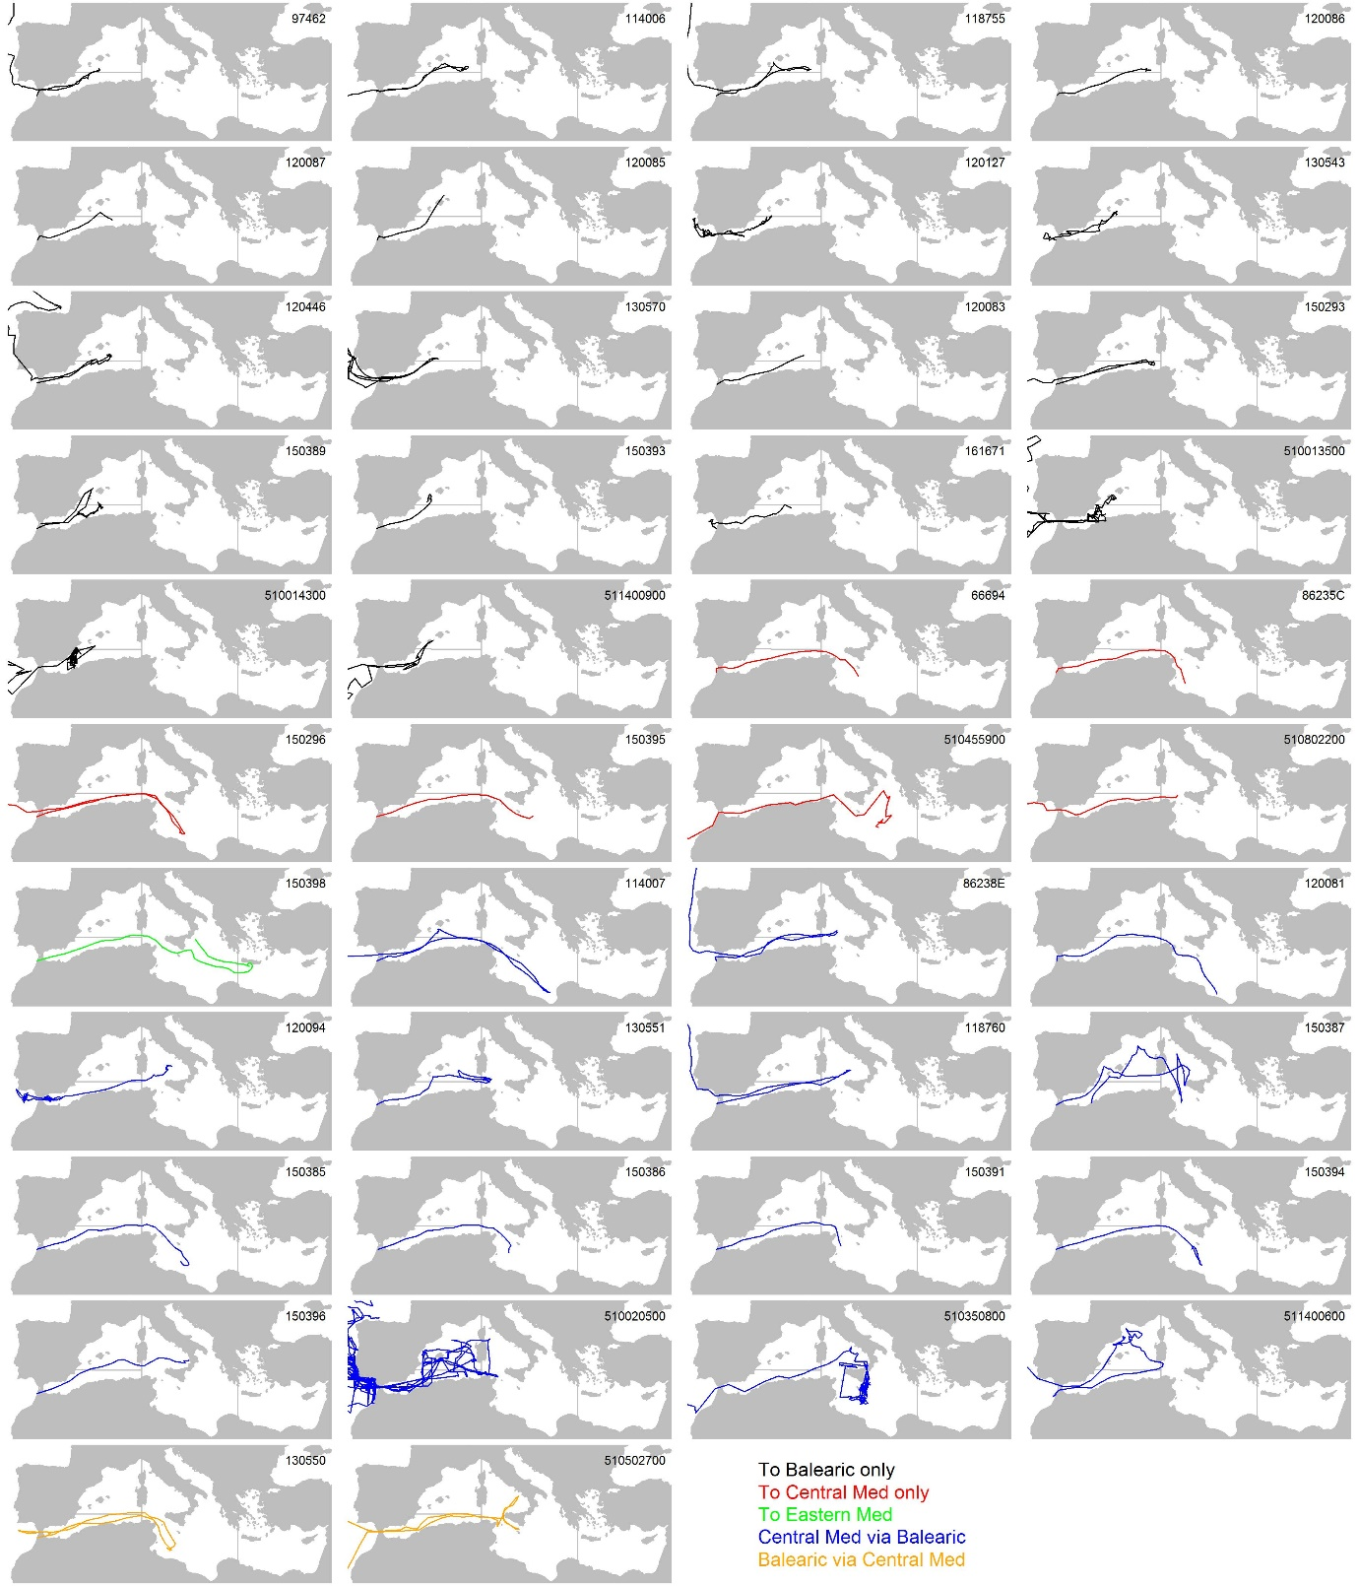

**Figure 4.** Electronic tag tracks for all tags entering the Mediterranean originating in the Atlantic organized by movement type.

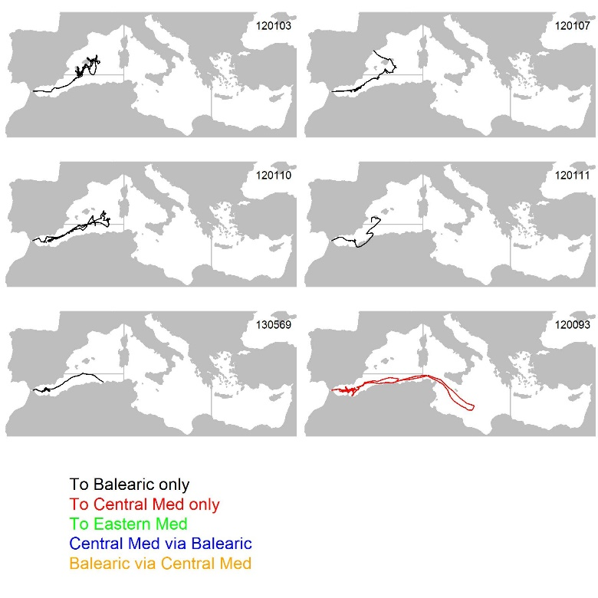

**Figure 5.** Electronic tag tracks for all tags entering the Mediterranean originating from the Strait of Gibraltar organized by movement type.

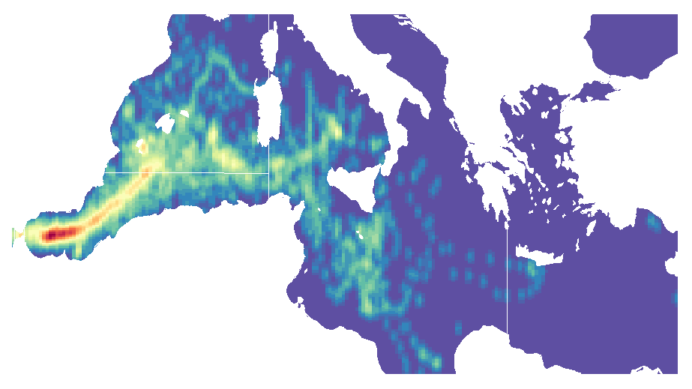**Figure 6**. Heat map of daily electronic tag density.

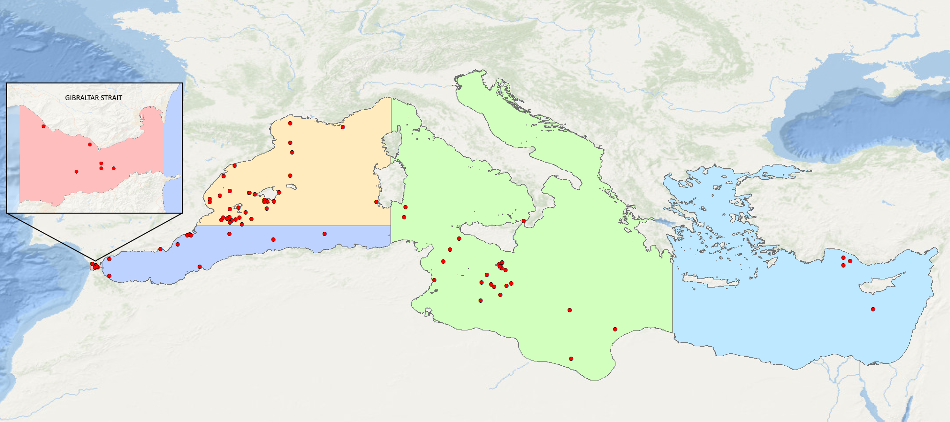

**Figure 7**. Distribution of the conventional tags deployed in the Atlantic Ocean which have been recovered in the Mediterranean Sea including the Strait of Gibraltar.

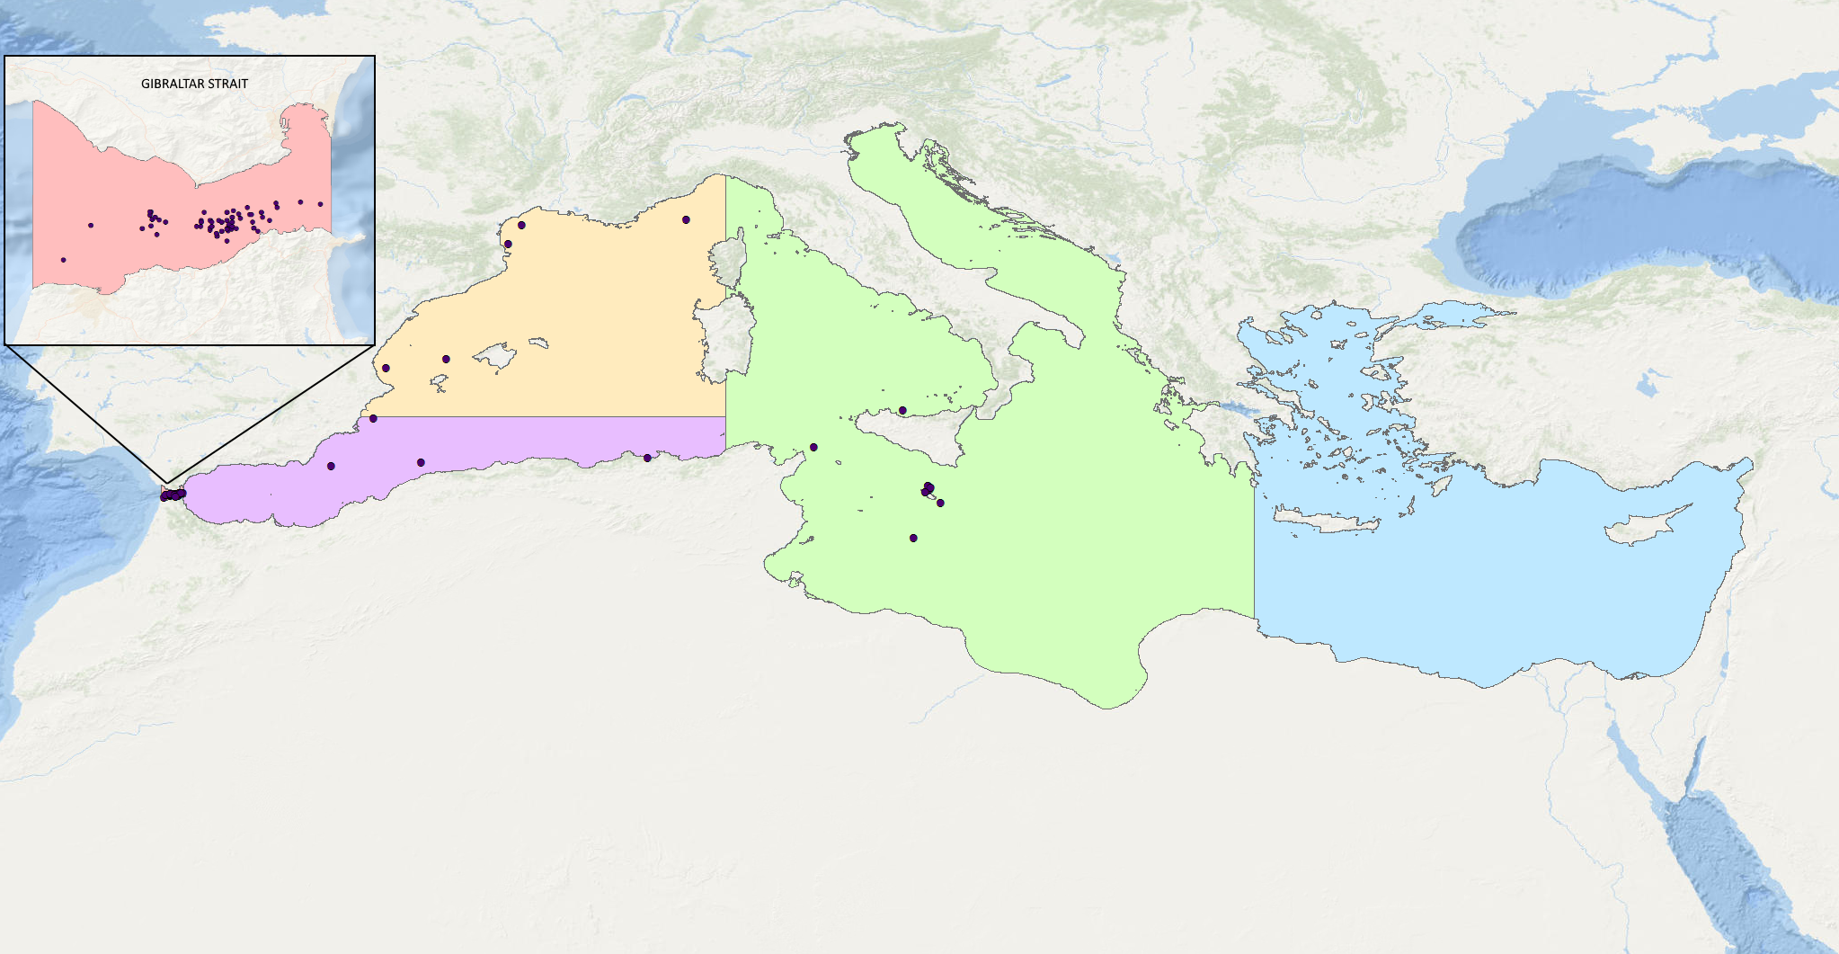

**Figure 8**. Distribution of the conventional tags deployed in the Strait of Gibraltar which have been recovered in the Mediterranean Sea and in the Strait of Gibraltar.

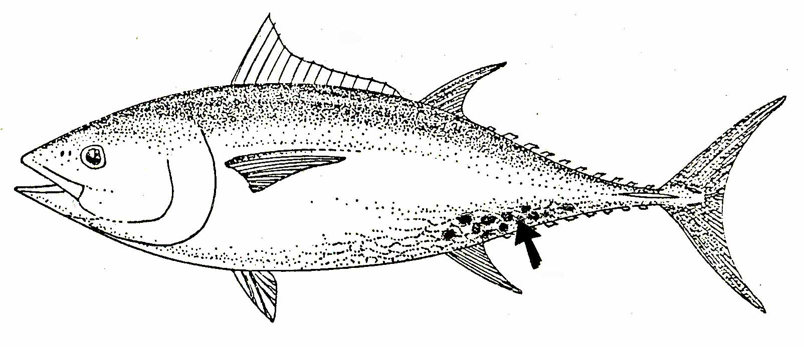

**Figure 9.** Schematic image of the preferred area where natural marks of *Isistius brasiliensiensis* usually occur on bluefin tuna.

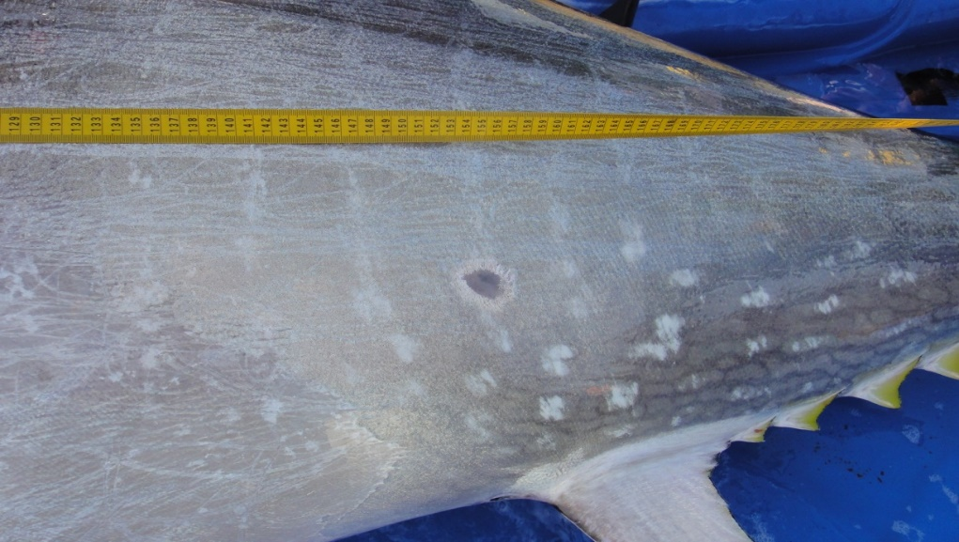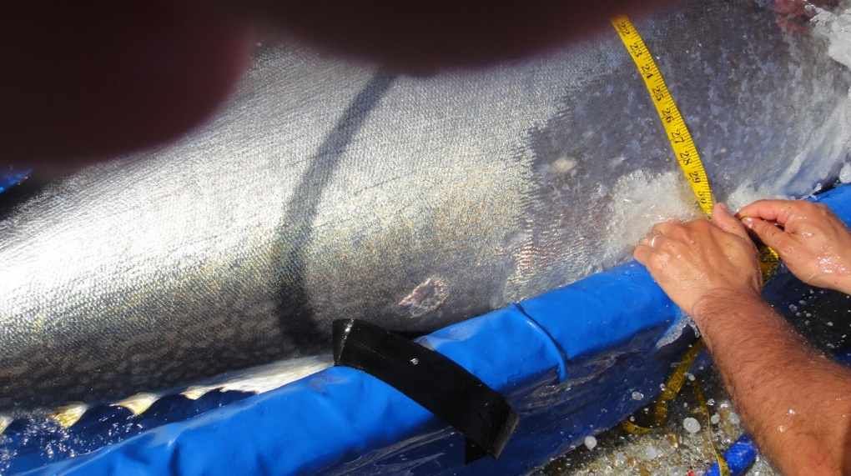

**Figure 10.** Natural marks on Bluefin tuna in the tuna trap in Larache (Morocco) in May 2012.

1. IOF, 2202 Main Mall, University of British Columbia, Vancouver, B.C., Canada, V6T 1Z4. [t.carruthers@oceans.ubc.ca](mailto:t.carruthers@oceans.ubc.ca)
2. GBYP, International Commission for the Conservation of Atlantic Tunas, ICCAT, Calle Corazón de María, 8, 28002 Madrid, Spain. [antonio.dinatale@iccat.int](mailto:antonio.dinatale@iccat.int); [alfonso.paga@iccat.int](mailto:alfonso.paga@iccat.int) ; [stasa.tensek@iccat.int](mailto:stasa.tensek@iccat.int)
3. U.S. National Marine Fisheries Service, Southeast Fisheries Center, Sustainable Fisheries Division, 75 Virginia Beach Drive, Miami, FL, 33149-1099, USA. E-mail: [matthew.lauretta@noaa.gov](mailto:matthew.lauretta@noaa.gov)
4. The Mediterranean purse-seine catches accounted for 50% to 62% of the total EBFT catches between 2011 and 2015 (Anon., 2017a, 2017b).
5. According to Di Natale and Idrissi (2012), since the beginning of the XX century and mostly in the second half of the century, the Bluefin tuna in the Mediterranean left the coastal migration in most of the areas, moving offshore to environmental changes (pollution, less transparent waters, acoustic noise, etc.).